EPOSTL ETAI 2016 Holli Schauber, Ed.D. University of Geneva
http://archive.ecml.at/mtp2/fte/pdf/C3_Epostl_E.pdf (free download)
EPOSTL: European Portfolio for Student Teachers of Languages
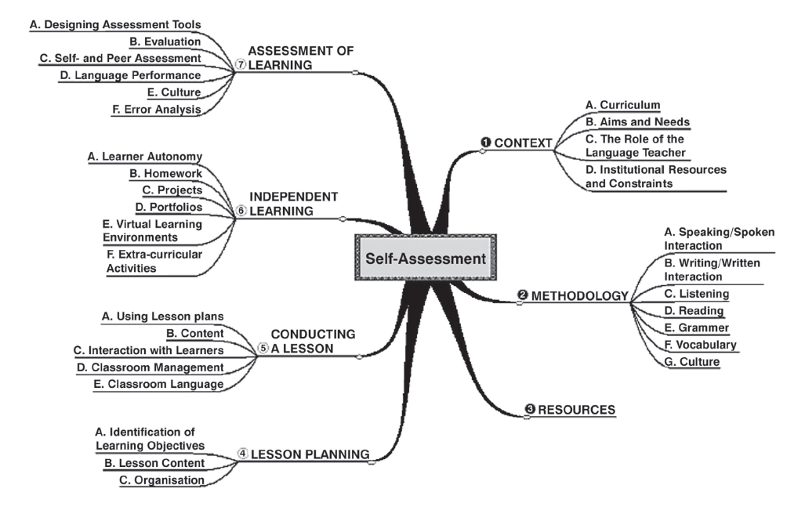
48 Descriptors for the 1st Attestation (need to achieve 70% of the following descriptors in their stage)

C. The Role of the Language Teacher

4. I can draw on appropriate theories of language, learning, culture etc. and relevant research
findings to guide my teaching.
6. I can critically assess my teaching in relation to theoretical principles.

Identification of Learning Objectives
1. I can identify curriculum requirements and set learning aims and objectives suited to my learners’ needs and interests.
5. I can decide whether to formulate objectives in terms of skills, topics, situations, linguistic systems (functions, notions, forms etc.).

B. Lesson Content
1. I can structure lesson plans and/or plan for periods of teaching in a coherent and varied sequence of content.
2. I can vary and balance activities to include a variety of skills and competences.
5. I can plan activities which link grammar and vocabulary with communication.
8. I can design activities to make the learners aware and build on their existing knowledge.
9. I can vary and balance activities to enhance and sustain the learners’ motivation and interest.

C. Lesson Organisation
1. I can select from and plan a variety of organisational forms (frontal, individual, pair, group work) as appropriate.
2. I can plan for learner presentations and learner interaction.

A. Using Lesson Plans
1. I can start a lesson in an engaging way.
6. I can fi nish off a lesson in a focused way.

B. Content
1. I can present language content (new and previously encountered items of language, topics
etc.) in ways which are appropriate for individuals and specifi c groups of learners.
2. I can relate what I teach to learners’ knowledge and previous language learning experiences.

B. Aims and Needs
5. I can take into account the affective needs of learners (sense of achievement, enjoyment etc.).
A.Speaking/Spoken Interaction

2. I can evaluate and select meaningful speaking and interactional activities to encourage learners of differing abilities to participate.
7. I can evaluate and select activities which help learners to participate in ongoing spoken exchanges (conversations, transactions etc.) and to initiate or respond to utterances appropriately.
10. I can evaluate and select a variety of techniques to make learners aware of, discriminate and help them to pronounce sounds in the target language.
11. I can evaluate and select a variety of techniques to make learners aware of and help them to use stress, rhythm and intonation.
12. I can evaluate and select a range of oral activities to develop accuracy (grammar, word choice etc.).

B. Writing/Written Interaction
2. I can evaluate and select a range of meaningful writing activities to help learners become aware of and use appropriate language for different text types (letters, stories, reports etc).
7. I can help learners to plan and structure written texts (e.g. by using mind maps, outlines etc.).

C. Listening
1. I can select texts appropriate to the needs, interests and language level of the learners.
2. I can provide a range of pre-listening activities which help learners to orientate themselves to a text.
4. I can design and select different activities in order to practise and develop different listening strategies (listening for gist, specifi c information etc.)

D. Reading
1. I can select texts appropriate to the needs, interests and language level of the learners.
2. I can provide a range of pre-reading activities to help learners to orientate themselves to a text.
5. I can set different activities in order to practise and develop different reading strategies according to the purpose of reading (skimming, scanning etc.).

E. Grammar
1. I can introduce a grammatical item and help learners to practise it through meaningful
contexts and appropriate texts.
2. I can introduce, and help students to deal with, new or unknown items of grammar in a
variety of ways (teacher presentation, awareness-raising, discovery etc.).
3. I can deal with questions learners may ask about grammar and, if necessary, refer to
appropriate grammar reference books.
5. I can evaluate and select grammatical exercises and activities, which support learning and
encourage oral and written communication.

F. Vocabulary
1. I can evaluate and select a variety of activities which help learners to learn vocabulary.
2. I can evaluate and select tasks which help learners to use new vocabulary in oral and written
contexts.

A. Resources
2. I can select those texts and language activities from coursebooks appropriate for my learners.
3. I can locate and select listening and reading materials appropriate for the needs of my learners
from a variety of sources, such as literature, mass media and the Internet.
5. I can design learning materials and activities appropriate for my learners.

D. Classroom Management
2. I can create opportunities for and manage individual, partner, group and whole class work.
3. I can make and use resources effi ciently (fl ashcards, charts etc.).

E. Classroom Language
1. I can conduct a lesson in the target language.
2. I can decide when it is appropriate to use the target language and when not to.
3. I can use the target language as metalanguage.
4. I can use various strategies when learners do not understand the target language.

C. Interaction with Learners
1. I can settle a group of learners into a room and gain their attention at the beginning of a lesson.
4. I can encourage learner participation whenever possible.

B. Evaluation
1. I can identify strengths and areas for improvement in a learner’s performance.
7. I can use a valid institutional/national/international grading system in my assessment of a learner’s performance.
8. I can assign grades for tests and examinations using procedures which are reliable and transparent.

F. Error analysis
4. I can deal with errors that occur in spoken and written language in ways which support learning processes and do not undermine confidence and communication.

holli.schauber holli.schauber@unige.ch

