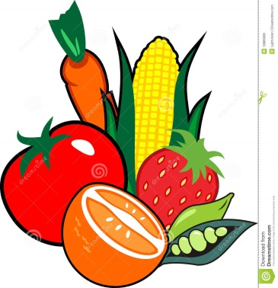
Snack Attack
Snack Attack

Name___________ My part_____________
Mom: Fred, Diana, find your snacks and meet me at the check-out in five minutes.
Fred: Quick! Chips and cookies in aisle three!
Diana: (runs) I want pretzels, bamba, chocolate.
Narrator : Diana ran through the fruits and vegetable but then stopped .
Fred: Come on, Diana!
Diana: Wait, I hear something!
Fred: What is it?
Apple: We are also snacks. Don't forget us!
Fred: Who's that?
Star fruit: Don't listen to that apple!
Diana: Who's talking?
Fred: I think it’s the fruits.
Star fruit: Why buy a plain little apple? You can buy me- a beautiful star fruit.
Banana: The star fruit is so self-centered. The banana is the most popular fruit in American. Americans eat about 13 kilos of a yar.
Diana: I like bananas but we are looking for good snacks: bisli, chips, candies. Right Fred?
Potato: So forget the fruit! what about the vegetables? Everybody loves a potato. We are really healthy.
Fred: That’s right! But we have to cook potatoes.
Onions: How about an onion? We are smelly but we have a lot of fiber!!
Green Beans: Everyone just takes the fruit
Broccoli: Why not just take me?
Apple: Think and choose an apple. We come in red, green, and yellow. But we all have fiber to make you strong.
Fred: Don't forget that an apple a day will keep the doctor away!
Apple: That’s right- pick an apple
Carrot: Just a minute there, Granny Smith. My bright orange color shows that carrots had have vitamin A and vitamin C.
Diana: And carrots are good for the eyes! Have you ever seen a rabbit with glasses?!?!
Lemon: How would you like to be squeezed?
Grapes: Now lemon, don't be so sour. We grapes come in lots of colors: green, red, purple.
Diana: I don't like seeds.
Grapes: We have grapes without seeds just for you.
Strawberries: Look at me! I have my seeds on the outside- all 200 of them!!
Fred: A bright strawberry is my favorite sweet fruit.
Hot pepper: I am not sweet , but I am really hot!!
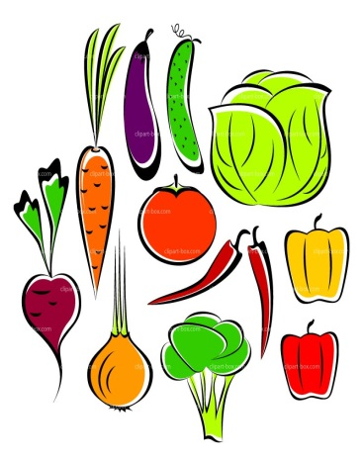
Apple: What do you say kids? Will you choose a fruit or vegetable?
Onion: They will never choose a vegetable. I want to cry!
Carrot: Diana, don't you want a tasty fresh, crunchy, carrot?
Diana: MMM!!! That sounds good!
Narrator: Diana took an apple from the shelf.
Green bean: Oooffff!! They always choose the fruit, but we can be a healthier snack.
All fruits: Fruit
All Vegetables: Vegetables!
Star fruit: this isn't a game of fruit Ninja. We want the kids to be healthy and eat us all.

Fruits and Vegetables: We are all good for them!
Mom: Where were you?
(Kids look at each other )
Fred and Diana: You will be so happy. Look what we have!! (all fruit and vegies)
Mom: Good for you!! I love you!
Cashier: Thank you very much!!

New words:מילים חדשות
______________________________________________________________________________________________________________________
_________________________________________________________________________________________________________________________________________________________________________________
תחפושת שלי
___________________________________________________________
Adapted from Snack Attack, Education World website
Parts in Snack Attack:
Number of lines for each part
- Fred: (7)
- Diana:(8)
- Mom(2)
- Narrator: (3)
- Apple:(3 long lines)
- Cherry:(1-long)
- Banana(1)
- Potato: (1)
- Onion: (2)
- Green Beans: (1)
- Carrot: (2)
- Grapes: (2)
- Strawberries:(1)
- Hot Pepper (1)

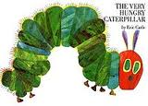
Hungry Caterpillar text: The Very Hungry Caterpillar
Adapted For the Readers' Theatre program by Sharon kleinerman, Ma. Orot Girls School

Parts:
Narrator 1: _____________
Narrator 2: ______________
Narrator 3:________________
Caterpillar# 1______________ Caterpillar#4______________
Caterpillar#2_______________Caterpillar # 5______________
Caterpillar# 3_______________Caterpillar #6 ______________
New words:____________________________________

Narrator 1: In the light of the moon, a little egg lay on a leaf.
Narrator 2: One Sunday morning, the warm sun came up and pop, out of the egg came a tiny and very hungry caterpillar. He started to look for some food.
Caterpillar#1: On Monday, the caterpillar ate one apple.
Narrator 3: But the caterpillar was still hungry!
Caterpillar #2 : On Tuesday, the caterpillar ate two pears.
Narrator 3: But the caterpillar was still hungry!
Caterpillar #3: On Wednesday: the caterpillar ate three plums.
Narrator 3: But the caterpillar was still hungry!
Caterpillar #4: On Thursday, the caterpillar ate four strawberries!
Narrator 3: But the caterpillar was still hungry!
Caterpillar# 5: On Friday, the caterpillar ate five oranges!
Narrator 3: But the caterpillar was still hungry!
Caterpillar #6: On Saturday, the caterpillar had one piece of chocolate cake, one ice cream cone, one slice of Swiss Cheese, one slice of salami, one lollipop, cherry pies, one sausage, one cupcake, and one slice of watermelon.
Narrator 1: And that night, the caterpillar had a stomachache.
Narrator 3: And on Sunday, he ate a big green leaf and he felt much better.
Narrator 2: He wasn't hungry, he wasn't little, he was a fat, big caterpillar.
He build a house called a cocoon and stayed inside for 2 weeks.
Narrator 1: And on Monday, he made a hole and came out!!
All: And he was a big, beautiful great butterfly !!!!

Sharon Kleinerman, MA, English and Special Education Teacher, Orot Girls School, Bet Shemesh, email: sharonkleinerman123@gmail.com

