**“The Adventure of the Speckled Band”**

**-Arthur Conan Doyle**

**LOG Literature Unit**

**Student Section**

**Table of Contents**

Unit Evaluation: The Adventure of the Speckled Band – Sir Arthur Conan Doyle 3

THE SPECKLED BAND Pre- Reading 4

Part I - Basic Understanding & Analysis 6

Part 2 - Basic Understanding & Analysis 7

Part 3 - Basic Understanding & Analysis 8

Part 4 - Basic Understanding & Analysis 8

Terms – Reader Mistrust & Theory of Mind in Detective Novels 10

HOT Skill: Uncovering Motives 12

HOT Skill - Making Connections 13

Making connections in the story “The Adventure of the Speckled Band” 13

Bridging Text and Context 14

Post Reading Task - Movie poster or Book Cover 14

Reflection Sheet - The Adventure of the Speckled Band 15

|  |  |  |  |  |  |
| --- | --- | --- | --- | --- | --- |
| Unit Evaluation: The Adventure of the Speckled Band – Sir Arthur Conan Doyle | | | | | |
| **Unit Grade:** | | | **Date:** | **Student name:** | |
| **Format Notes:**  **Content notes:** | | | | | |
| **Grade** | **in the Log** | **Short Description of Activity** | | | **Key Components** |
| **Yes / No** |
| X |  | **Pre – reading activity handout (filled out)**  **Discussion: invention of the Genre, "ratiocination", what typifies this genre - notes** | | | 1. Pre-Reading |
| X |  | Part 1  **Questions & Vocabulary** | | | 1. Basic Understanding & Analysis part 1 |
| X |  | Part 2 **Questions & Vocabulary** | | | 1. Basic Understanding & Analysis part 2 |
| X |  | Part 3 **Questions & Vocabulary** | | | 1. Basic Understanding & Analysis part 3 |
| X |  | Part 4 **Questions & Vocabulary** | | | 1. Basic Understanding & Analysis part 4 |
| X |  | **HOTS – Making Connections** | | | 1. Analysis and Interpretation |
|  |  | **Term: Theory of Mind & reliability** | | |
| X |  | * **Victorian period** * **Doyle spiritualism** * **Animals in Victorian literature** | | | 1. Bridging Text and Context |
|  |  | **poster / Illustration / book cover (graded) (30%) class project** | | | 1. Post-Reading Activity* |
| X |  | **Reflection** handout (page with teacher comments in log) | | | 1. Reflection** |
|  |  | Summative assessment (**graded**, in log, 50%) | | | 1. Summative Assessment |
|  |  |  | | | **TOTAL** |

|  |  |  |  |
| --- | --- | --- | --- |
| **Element** | **% of Grade for Unit** | **Grade** | **Points** |
| Unit contains all the required activities | 20% |  |  |
| Graded Key Component(s) - Post reading activity | 3**0%** |  |  |
| Summative Assessment | 50% |  |  |
| Total |  |  |  |

THE SPECKLED BAND Pre- Reading

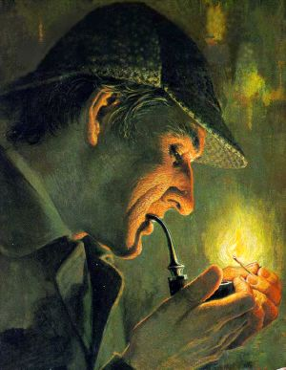**Think of some detective mysteries you have read and read a little on the internet.**

1. **Who is considered the “inventor” of modern detective fiction? What did he write and who was the detective?**

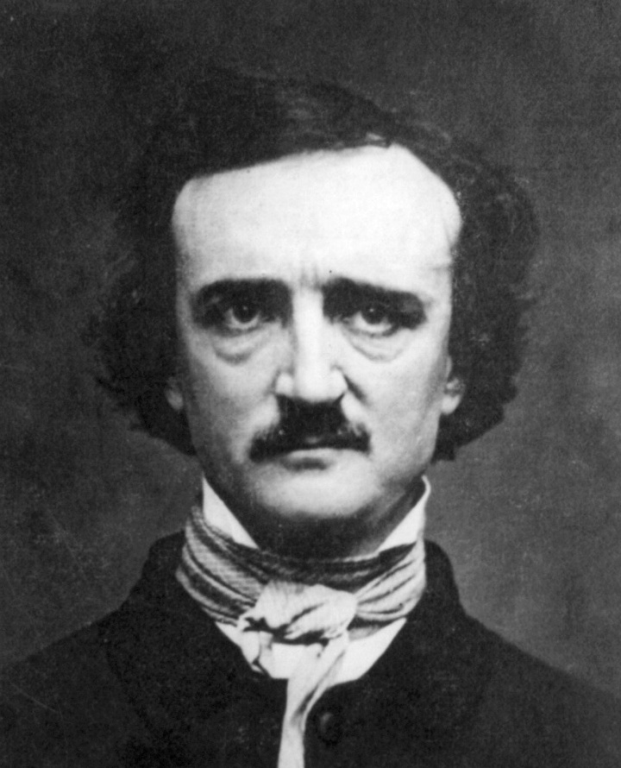

***The author considered the inventor of modern detective fiction is Edgar Allen Poe, who wrote The Murders in the Rue Morgue*, 1841;   
*The Mystery of Marie Rogêt*, 1842/43; and *The Purloined Letter*, 1844. The name of his detective was August Dupin.**

1. **What do you think is *typical* of the detective genre? What kind of characters do we expect to see, what kinds of events, setting etc.? What is the story plot usually like?**

***In the detective genre, we expect to encounter a mystery – the theft of a valuable jewel, a stolen letter or the murder of one or more people.***

* ***Typically there is one character who serves as the intelligent and perceptive detective, and often there is a supporting character that helps him.***
* ***The supporting character provides information readers need – it asks questions, describes the circumstances and is often “clueless”. It is less brilliant than the detective and in constant need of elucidation.***
* ***Other characters that might or might not be involved in the crime populate the story. The special feature of detective stories is that readers must treat all these characters as potential criminals. Readers thus cannot allow themselves to believe the characters (as they often tend to do in other genres), and must constantly question the validity of anything any character says.***
* ***Detective mysteries often occur in cities or villages (rather than in nature) and involve complex human relationships***
* ***Most mysteries open with a crime and a detective who is called in to solve it. As time progresses more and more clues are collected (some misleading) and information is revealed – but not the murderer / criminal. Towards the end of the story the detective reaches his / her conclusion and makes the truth known, thereby apprehending the criminal (or, in special cases, letting the criminal go free).***
* ***One of the pleasures of detective fiction stories is “guessing” who the criminal really is!***

1. **How is the detective genre *different* from other types of stories / plays we have read? How is it similar?**
2. 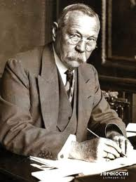**Sir Arthur Conan Doyle lived in the years 1859-1930. Who & what was he? Write 5 facts about him that you think are interesting and may give us insight to his stories.**
3. **There have been many remakes of Sherlock Holmes.   
   Look up *two* different *actors* who have played Sherlock Holmes.**
   1. **Insert their pictures below**
   2. **Write down their names and when they acted**
   3. **Were they successful and popular ? Find some opinions about their acting in forums / blogs etc. and write a few below**

Name:

Date:

Name:

Date:

**Opinions in forums / blogs / personal:**

|  |
| --- |
|  |
|  |
|  |
|  |
|  |
|  |
|  |
|  |

Part I - Basic Understanding & Analysis

1. **Look up the present definition of “knocked up”. Does it match the meaning in the text (p. 1)? How can you tell?**
2. **Create a dictionary for 5 complex words; be sure you understand all the words in bold.**

|  |
| --- |
|  |
|  |
|  |
|  |
|  |

1. **Who is telling the story to the reader? (who is the narrator)**
2. **What is the setting for the external “frame” story, and what is the setting for inner frame story? (the one told by the visitor)**
3. **What is a “dog cart” and how can Sherlock Holmes tell that the visitor came by dog cart?**
4. **Write 3 non-trivial LOTS questions (directly found in the text) and answer them**
   1. ________________________________________________________________________
   2. _______________________________________________________________________

* 1. ________________________________________________________________________

1. 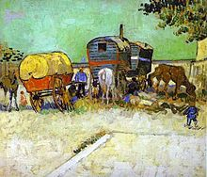**Why do you think the gypsies are mentioned?**

Part 2 - Basic Understanding & Analysis

1. What do we know about the character “Dr. Grimesby Roylott” ? Give 3 qualities / facts and support these with information from the text.
   1. ____________________________________________________________
   2. ____________________________________________________________
   3. ____________________________________________________________
2. **Create a dictionary for 5 complex words; be sure you understand all the words in bold.**

|  |
| --- |
|  |
|  |
|  |
|  |
|  |

1. **“I have seen the will of the deceased wife," says Holmes. Why was Holmes interested in the will?**
2. **“if both girls had married, this beauty would have had a mere pittance, while even one of them would cripple him to a very serious extent”**
   1. **Who does “this beauty” refer to? (what kind of literary technique is this ?)**
   2. **What does it mean “a mere pittance” ?**
   3. **What does it mean “even one…would cripple him” ?**
3. **What is an “Eley's No. 2**“ ?
4. **Holmes says: “we have every reason to believe that the doctor has an interest in preventing his stepdaughter's marriage”.** 
   1. **Why does the doctor have an interest in preventing the marriage?**
   2. **Which HOTS explores such questions of why people behave in different ways?**

Part 3 - Basic Understanding & Analysis

1. **Create a dictionary for the following words and expression as they are used in the text. Be sure you understand all the words in bold.**

|  |
| --- |
| 1. **Lichen** |
| 1. **Blotched** |
| 1. **In repair** |
| 1. **Little better** |
| 1. **Bolted** |
| 1. **Save for** |
| 1. **Dummy** |
| 1. **Iron safe** |
| 1. **Squat** |
| 1. **tangible** |

1. **Describe the room in which Miss Stoner’s sister died (and in which she now hears the whistle). What items seem strange to Sherlock Holmes?**
2. **The building in which Miss Stoner lives has a central portion and two wings. Sketch the building (bird’s eye view) and using arrows show which parts are in ruin and which part is the one in which the family resides.**
3. When Holmes says “there does not seem to be any very **pressing** **need** for repairs at that end wall” what does it mean? What does Miss Stoner think is the reason for the repairs?
4. **Watson says: “**To me at least there was a strange contrast between the **sweet promise of the spring and this sinister quest”. What do you think he means?**
5. **On basis of Holmes’s observation of the milk, leash and closed safe – what might we predict is the creature in the safe?**

Part 4 - Basic Understanding & Analysis

1. What was the “**speckled band**”? What were some of its qualities?
2. How was it used by Dr. Grimesby Roylott?
3. **Create a dictionary for the following words and expression as they are used in the text. Be sure you understand all the words in bold.**

|  |
| --- |
| 1. **Engage** |
| 1. **deduced** |
| 1. **coroner** |
| 1. **coroner’s inquiry** |
| 1. **clamped** |
| 1. **somber** |
| 1. **writhing** |
| 1. **vigil** |
| 1. **at liberty** |
| 1. **befall** |
| 1. **ajar** |
| 1. **clad** |
| 1. **protruding** |
| 1. **prolong** |
| 1. **indiscreetly (playing)** |
| 1. **dispel doubts** |

1. Holmes refers to **Palmer and Pritchard. Who were they** ? **Why** do you think they are mentioned?
2. **Holmes provides an *aphorism,* or “wise” saying*:*    
   “Violence does, in truth, recoil upon the violent, and the schemer falls into the pit which he digs for another”**  Explain how it applies to the story. Can you apply it to an event / person in real life?
3. The **detective’s** work is based on deducing facts and finding motivations for the crime.
   1. What **motivated** Dr. Grimesby to enact the crime?
   2. Was it a **simple** or **complex** motive? Explain.
4. **In view of what Holmes says, why do you think the gypsies were discussed in the story?**

Terms – Reader Mistrust & Theory of Mind in Detective Novels

**We sometimes call our ability to “read” what other people feel and think “Theory of Mind”**

* **Although this ability is in part “innate” – existing at birth, part of our being humans (and animals) , it is also developed as we grow and watch other people.** 
  + **Normal babies learn how to interpret expressions by watching other people**
  + ***Autistic children* have a very hard time understanding how others feel; they have problems with constructing a theory of mind**
* **When we visit new cultures and places in the world, we watch how other people act and learn what they mean.** 
  + **Often, what is perceived as friendly or “yes” in one culture, may not be perceived that way in another culture!**
* **“Theory of mind” is required for *making inferences*. As we know, Inferences are often INACCURATE.**

**Theory of Mind in literature**

**When authors write stories, they rely on our theory of mind, or our ability to understand how other people think and feel**

* **We apply our skills to characters and figure out from descriptions how the characters think and what they want**
  + **What do we think when a character’s hands tremble?**
  + **What do we assume when a character’s eyes sting with tears?**
* **Authors rarely tell us that a character went to the bathroom or slept a full night; we assume this is true because we apply our own normal human habits to story characters**
* **We also make inferences and assumptions about the characters’ motives and events in the story**

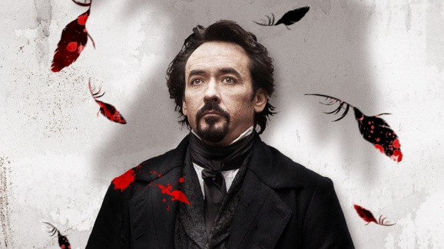

**Tricks and Distrust**

**Authors also use our theory of mind to “trick” us. They know we assume certain things, and then they surprise us. This makes reading interesting. We also become interested in the author’s mind: why did he / she choose to show us something?**

* 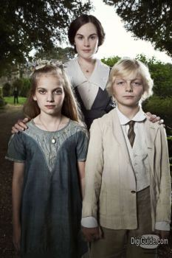**Certain characters that we meet are marked ahead of time by the author as “unreliable” - they may be sick or *hallucinating*, and we as readers know not to trust them so much**
* **But sometimes characters that sound very reliable and trustworthy end up as liars and then the whole story is turned upside down**
* 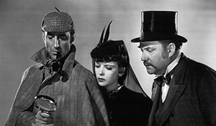**In Detective stories, readers know NOT to trust ANYONE – all characters (except perhaps the detective and his helper) may be suspect.**
* **Therefore readers must be in “a constant state of vigilance” (as Lisa Zunshine terms it ) constantly suspicious – just like the detective investigating the mystery.**
* **Reader *mistrust* is at the basis of the detective story**

**From “Why We Read Fiction” – Lisa Zunshine (2006)**

**“ In other words, we open a detective novel with an avid anticipation that our expectations will be systematically frustrated, that we will be repeatedly made fools of, and that for several hours….we will be fed deliberate lies in lieu of being given a direct answer to one single simple question that we really care about (i.e., who done it?)”**

**Ellen R. Belton observes that the reader of the detective story is motivated “by two conflicting desires: the desire to solve the mystery ahead of or at least simultaneously with the investigator and the desire not to solve it until the last possible moment in order to prolong the pleasures of the mystery situation.”… I do not think that many of us would find such a suspended state particularly delectable in real life. “**

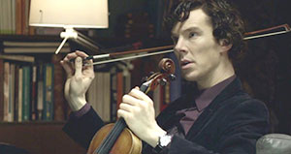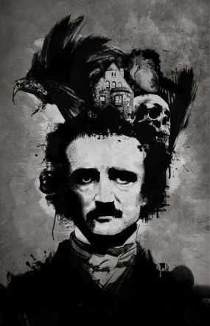

HOT Skill: Uncovering Motives

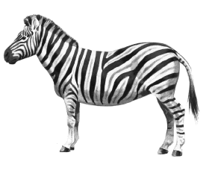**Motive means the “reason for doing something”.**

**What might be the motive for people going to a health club? __________________________________________**

**What might be the motive for purchasing a zebra? ___________________________________________________**

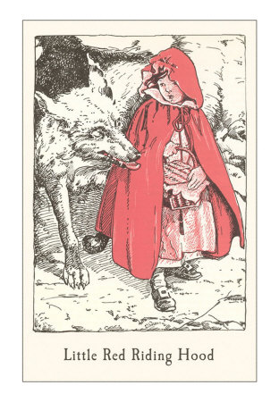

**When we “uncover motives” in literature, we identify reasons for a character’s behavior and support this with evidence from the text.**

* In “The Little Red Riding Hood” – Why is LLRH going through the forest with a basket?
* What motivates the wolf to go to Grandmother’s house?

“Uncovering Motives” is especially important in a **detective mystery. The detective character must apply this skill in order to figure out *who committed the crime.***

What are some **motives** a character might have for committing murder?

* Money
* Jealousy
* Revenge
* Hiding some important personal information
* 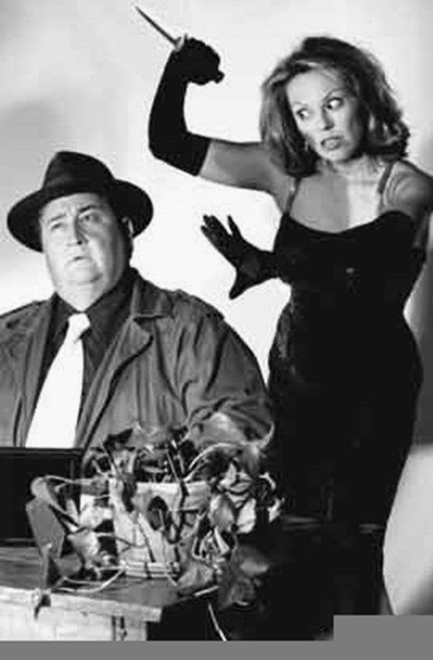 ____________________________________________

In “T**he** **Speckled Band” – what were the motives for murdering Julia and for attempting to murder Helen?**

_____________________________________________________________

Examples for questions:

* Why do you think that __ did __? Support your answer.   
  What made ___ change his/her mind? Give supporting details.
* The character _________________________________ in the book / story _________________________

(did, built, destroyed, prepared, searched for ….)

in order to ____________________________________________________.

HOT Skill - Making Connections

When we **make connections** in life, we take different pieces of information and see what conclusions we reach. We reach conclusions, or “deduce” by collecting separate facts.

This is similar to making ***inferences*** on basis of information we get.

**Example 1**

* **You hear on the radio that the president of the United States of America is coming to visit Tel Aviv tonight.**
* **As you drive to Tel Aviv to visit a friend, you see a *terrible* traffic jam and many police cars.**

**What conclusion could you make? Would you *connect* the two things?**

**Example 2**

* **As you walk in the hallway, you hear a teacher shouting in the class!**
* **A minute later you see your friend walking out of the door, looking embarrassed.**

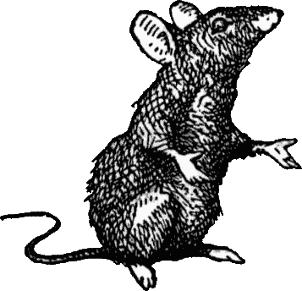**What conclusion could you make? Would you *connect* the two things?**

* **Now you see your friend running back to class with a *small* *cage.*  What connection could you make?**

**When we use the thinking skill “making connections” in literature, we:**

* **make connections between specific aspects of the text**
* **make connections between the text and *other contexts* in relation to historical, and cultural contexts or pertinent information from the author’s biography.**

**Some Questions we might ask about a story or a poem:**

* How does the description of the **setting** connect to the **events that happen**?
* To what extent do **events** in the **text** reflect **events** in the **life** of the author?

Making connections in the story “The Adventure of the Speckled Band”

1. **What connection does Holmes make when he hears that Miss Stone’s sister could smell Dr. Roylott’s cigar? What does he *deduce*?**
2. **At the end of the story, Holmes says to Watson:**

**"Well, there is at least a curious coincidence of dates. A ventilator is made, a cord is hung, and a lady who sleeps in the bed dies." Holmes also notices that the bed is fastened to the floor. What does he deduce?**

Bridging Text and Context

**An important aspect of the Victorian period is the large-scale expansion of British imperial power.  During the 19th century, the British Empire expanded its colonial presence in many countries including India. British colonists were often ambitious men who felt they could become rich and successful by working in the colonies. Unfortunately, for some the sense of power over the natives led them to become violent and they abused and exploited the natives.**

**[adapted from** [**http://faculty.unlv.edu/kirschen/handouts/victorian.html**](http://faculty.unlv.edu/kirschen/handouts/victorian.html)**]**

**Connect this quote to the story.**

Post Reading Task - Movie poster or Book Cover

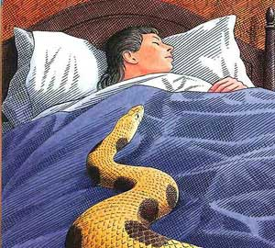**Some information on your PRT:**

* **Point value: 30% of the unit grade**
* **You may work in pairs**

**Create a poster for a Sherlock Holmes movie or a book cover, or a poster illustrating a particular scene in the story.**

* **The size needs to be is A3 or folio so it can be folded into your log.**
* **The background must be colorful**
* **You must include elements from the story accurately**
* **The illustration /poster / cover must be exciting and cause people to want to read the book / see the movie**
* **Interesting color schemes, textures, use of fabric / collage / etc are encouraged!**
* **You must include a half page explanation of your illustration / poster: which scene / event, are included, and what do the elements signify?**

Post Reading Activity Assessment Rubric

|  |  |  |
| --- | --- | --- |
| **Illustration, Poster or Book cover** | **value** | **points** |
| **Content & format**   * **The poster / cover / illustration follows the content & format requirements** * **It is clear an effort was made in preparing the project** * **The cover obviously represents the story and shows elements of the story** | **80** |  |
| **Explanation – well written, grammatically correct and describes the poster / illustration clearly** | **20** |  |
| **Total** |  |  |
| **Comments:** | | |

Reflection Sheet - The Adventure of the Speckled Band

|  |
| --- |
| 1. **Did you enjoy reading the story? Explain why or why not – what did you find interesting, surprising, etc.?** |
| 1. **The HOTS “making connections” helps us connect pieces of information in the story to one whole “picture”. Sometimes authors “hide” certain bits of information. This is particularly true in detective fiction. Why do think it is important?** |
| 1. **Is applying the HOTS “Making Connections” the same for real life as for stories? Explain.** |
| 1. **Can you apply the skill you learned to other subjects at school? Explain** |