**Ready for School**

**(from "English is More Fun", Kara Aharon)**

* *color items from each verse in a different color,* ***or***
* MCj03972040000[1]*draw a line between items named in each verse*

MC900325638[1]

MCj03980530000[1]

MC900290934[1]

MC900301514[1]MCj04041210000[1]

MCj03254460000[1]

MC900287345[1]j0307923MCj04040590000[1]

**Good Morning to the Sun**

**(from "English is Fun", Kara Aharon(**

*Fill in the past tense verbs using the chart below - some words appear more than once.*

I _____ up in the morning and I ____ right out of bed

I _______ to the window and ________ out,

______ the sun and ______

Good morning to the sun, good morning everyone

It’s good to see the sun shine on everyone.

MCj03495730000[1]I ______ on my shirt and ______ on my pants,

______ on my socks and shoes.

I ______ outside and _______ my friends

And _______ them what _____ new.

Good morning to the sun, good morning everyone

It’s good to see the sun shine on everyone.

I ____ to school and ____ in class until the afternoon.

I _______ outside till the sun ______ down

And then I _______ the moon

Good evening to the moon, good evening to the stars

Now the day is _______, good evening everyone.

|  |  |  |  |  |  |  |  |
| --- | --- | --- | --- | --- | --- | --- | --- |
| **Past** | **Present** |  | **Past** | **Present** |  | **Past** | **Present** |
| asked | ask |  | put | put |  | stayed | stay |
| done | do |  | said | say |  | was | is |
| got | get |  | sat | sit |  | went | go |
| looked | look |  | saw | see |  | woke | wake |

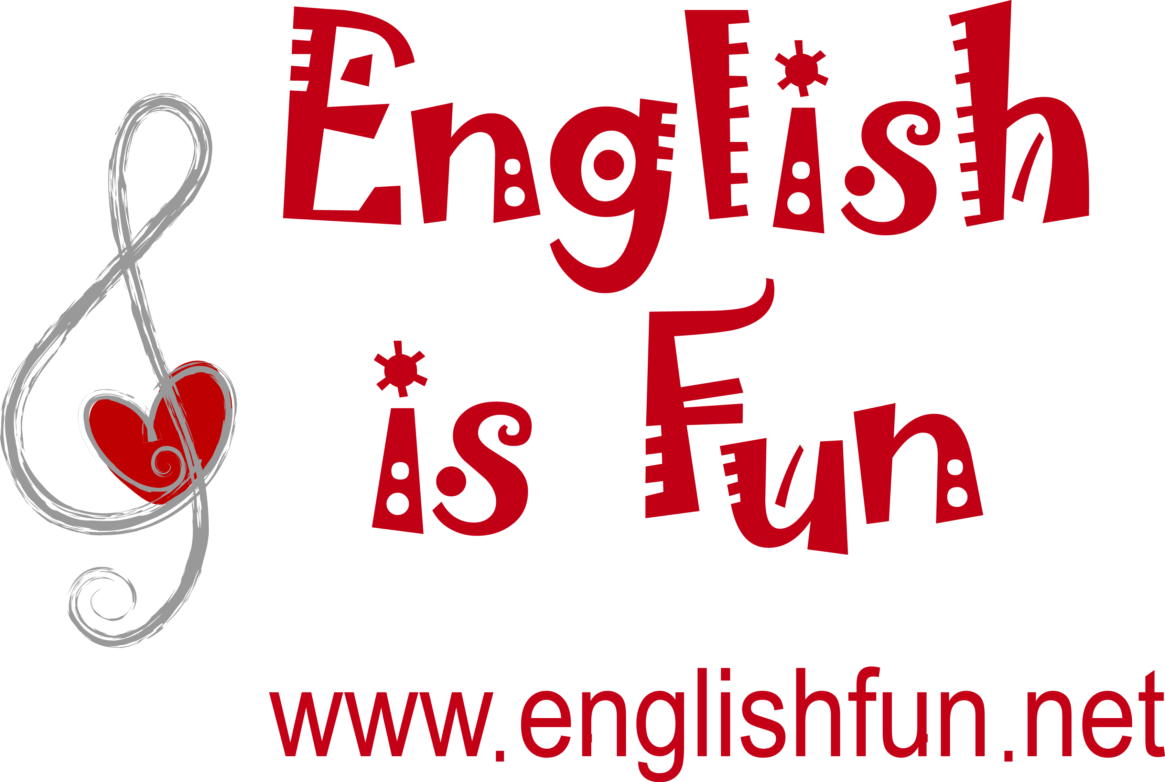

**A Long Short Walk**

**(from "English is Fun as You Advance", Kara Aharon)**

A fat man and a short woman took their big brown dog on a very long walk.

From their old house they went outside, the street was quiet and they started to talk.

The dog barked loudly at a pretty cat, who climbed quickly up a tall green tree.

The sun was hot and the cars went slow and they were as happy as they could be.

A thin man and a tall woman took their small brown dog on a very short walk.

To their new house they went inside, the street was noisy and they couldn't talk.

The dog barked softly at an ugly cat, who climbed slowly up a short brown tree.

The sun was cold and the cars went fast and they were as sad as they could be.

A short man and a fat woman took their long brown dog on a very big walk.

From their quiet house they went outside the street was old and they started to talk.

The dog barked pretty at a loud cat, who climbed tall up a quick green tree.

The sun went slow and the cars were hot and they were as happy as they could be.

A tall man and a thin woman took their short brown dog on a very small walk.

To their noisy house they went inside, the street was new and they couldn't talk.

The dog barked ugly at a soft cat, who climbed short up a slow brown tree.

The sun went fast and the cars were cold and they were as sad as they could be.

* Mark all the adjectives.
* List pairs of opposites

|  |  |  |  |  |
| --- | --- | --- | --- | --- |
| long | short |  |  |  |
|  |  |  |  |  |
|  |  |  |  |  |
|  |  |  |  |  |
|  |  |  |  |  |
|  |  |  |  |  |

* Copy 5 sentences from the song that don't make sense.

**How Do You Do That?**

**(from "English is Fun as You Advance", Kara Aharon)**

*Fill in each blank with the proper form of do.*

*Present tense:*

A: How _________ you _________ that?

B: How _________ I _________ what?

A: How _________ you _________ what you're _________ right now?

B: How _________ I _________ what I'm _________ right now?

A: Yes, how _______ you _______ what you're ________ right now?

B: But I stopped _________ what I was _________.

*Past tense:*

A: How did you _________ that?

B: How _________ I _________ what?

A: How _________ you _________ what you _________ just now?

B: How _________ I _________ what I _________ just now?

A: Yes, how _______ you _______ what you _________ just now?

B: I forgot how I _________ what I _________ just now!

A: Then you can never _________ it again!

*Present tense:*

B: But look what I'm _________ now!

A: I can _________ what you're _________ now!

B: Good for you, now let's play a game.

You _________ something and I'll _________ the same.



Here are some of the ideas I mentioned:

* Have pupils listen to a song and identify words they know.
* Hand out lyrics with words missing, after they fill in the words let them check themselves by listening to the song again.
* Use lyrics as a dramatic reading (Who Says - Selena Gomez).
* Stage the song as a clip or skit (Rise and Shine).
* Have pupils write additional lyrics (You Can't Always Get What You Want, Let the Sunshine In).
* Other good familiar songs for use in class - We Are the World, Don't Laugh at Me, I Was Here, Hello Goodbye.
* Search for lyrics by title or language chunks -[http://www.lyricsnmusic.com/](http://www.google.com/url?q=http%3A%2F%2Fwww.lyricsnmusic.com%2F&sa=D&sntz=1&usg=AFQjCNHdqN5r9pMP8CM6NcOBbFSSyT3zNw)
* Always review lyrics and clips carefully before using in class.